**MONGO DB**

* It is a NoSQL (Not Only SQL) database.

Comparison to SQL database

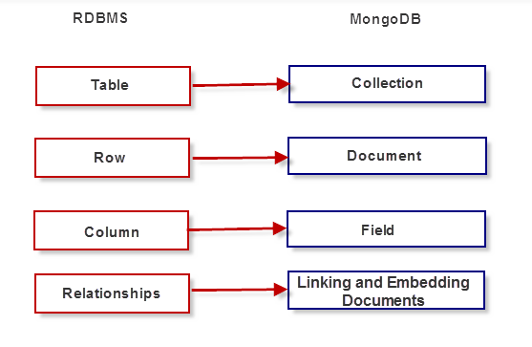

Mongo DB uses BSON or Binary JSON